Task: Created a NIC attached NIC to the created VM
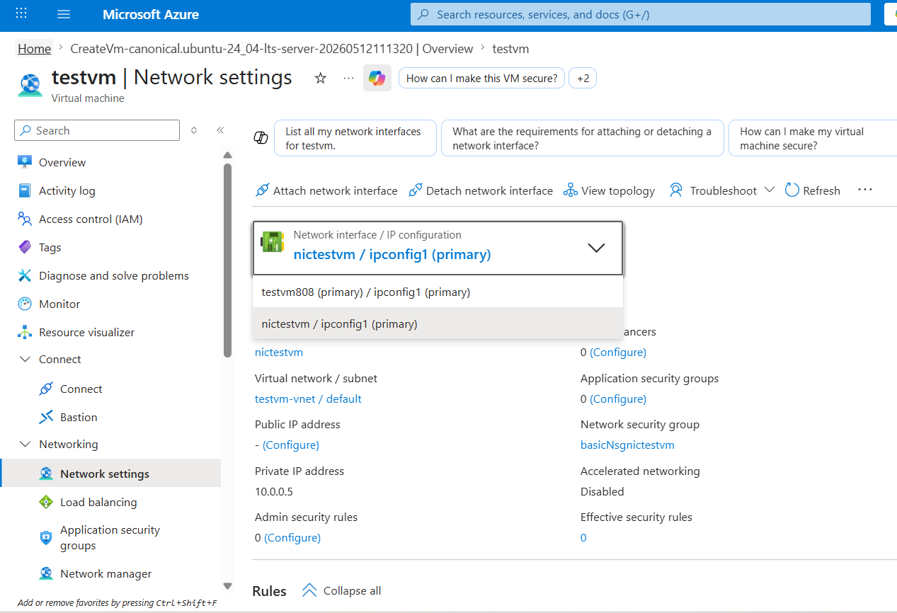
Created a Network Security Group to the subnet in which VM has been deployed 4. Open NSG rules for subnet and VM on port 80
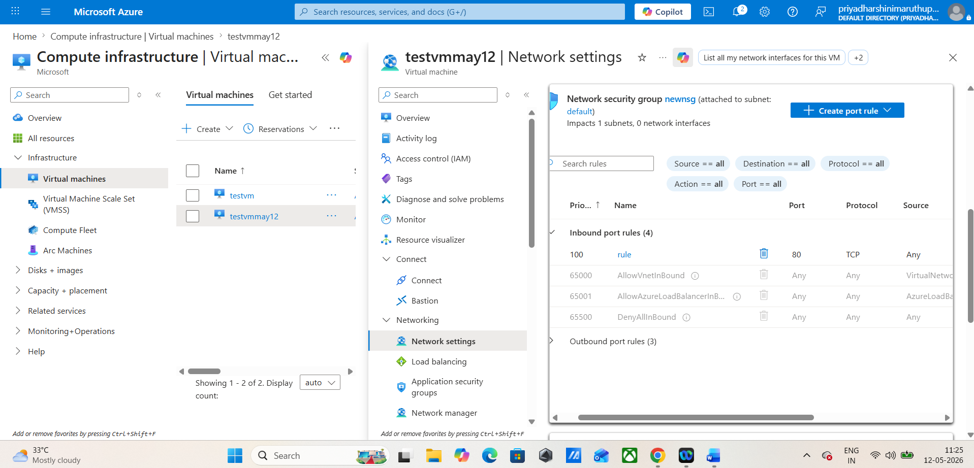

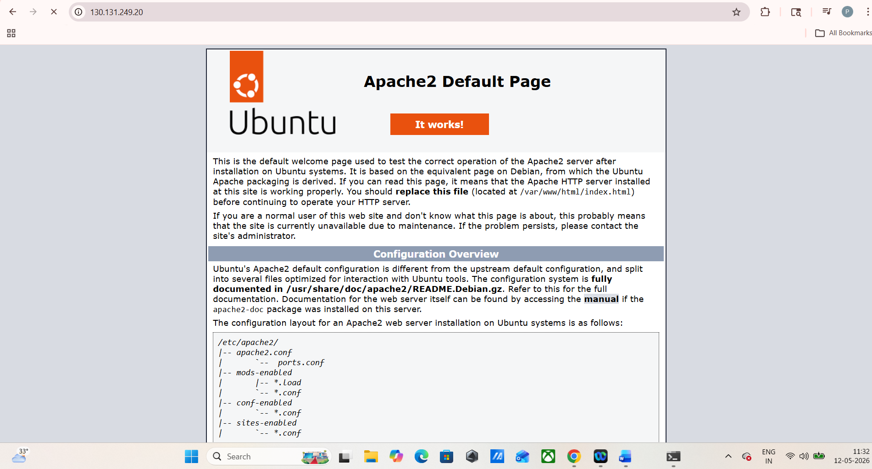


DNS configured
